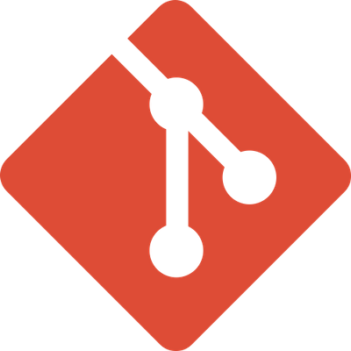**GIT**:

Git is a distributed version control system, as described earlier. It is the underlying technology that allows developers to track changes in their codebase, collaborate with others, and manage different versions of their projects.

* **What it is:** Git is a version control system (VCS). It's a software tool that tracks changes in your code over time. Imagine it as a time machine for your project, allowing you to revisit older versions or revert to specific points in its history.
* **Key features:**
  + Tracks changes and versions of your code.
  + Enables collaboration among developers.
  + Creates branches for isolated development and merging changes.
  + Offers a distributed system where everyone has a complete project history.
  + It allows developers to work on projects simultaneously without interfering with each other’s work.
  + Git tracks changes to files, maintains a history of revisions, and enables collaboration through features like branching and merging.
* **Where to use it:** Git is used locally on your machine to manage your project's codebase.



**GITHUB:**

GitHub is a web-based platform built around Git. It provides hosting for Git repositories and offers additional features to facilitate collaboration, such as issue tracking, pull requests, project management tools, and more. GitHub allows developers to share their code with others, contribute to open-source projects, and collaborate with teams remotely. Think of it as a central location to store your code, collaborate with others, and share your projects with the world.

* **Key features:**
  + Provides a user-friendly interface for Git functionalities.
  + Enables remote storage and management of Git repositories.
  + Fosters collaboration through features like pull requests and issue tracking.
  + Offers version control features like branching and merging.
  + GitHub is a platform built around Git.
  + It provides a web-based interface for Git repositories.
  + Developers use GitHub to host their Git repositories.
  + It includes features for collaboration, code review, issue tracking, and project management
* **Where to use it:** GitHub is a web application you access through a web browser.

Git and GitHub are closely related but serve different purposes.

In summary, Git is the version control system, while GitHub is a hosting platform that utilizes Git for version control and adds collaborative features on top of it. However, it's worth noting that while GitHub is the most popular platform, there are other alternatives such as GitLab and Bitbucket that provide similar services.

Git and GitHub are two powerful tools commonly used together for software development, but they serve different purposes:

**Analogy:**

Imagine a document you're working on. Git would be like constantly saving different versions of the document on your computer, allowing you to go back if needed. GitHub would be like uploading those saved versions to a cloud storage service where you can share them with others and collaborate on the document.

**DIFFERENCES:**

Here's a breakdown of the key differences between **Git, GitHub,** and **Google Drive**:

**Purpose:**

* **Git:** Version control system (VCS) for tracking changes in code or any kind of file. It focuses on maintaining a history of changes and allowing you to revert to previous versions.
* **GitHub:** A hosting platform for Git repositories. It provides a user-friendly interface, collaboration features, and version control functionalities built on top of Git.
* **Google Drive:** Cloud storage service for storing and sharing various file types (documents, spreadsheets, presentations, etc.). It allows collaboration on documents but doesn't offer the version control features of Git.

**Functionality:**

* **Git:** Offers powerful features like branching for isolated development, merging changes, and conflict resolution. It has a command-line interface which can be complex for beginners.
* **GitHub:** Provides a web interface and mobile app to interact with Git repositories easily. It offers collaboration features like pull requests for code review and social coding functionalities.
* **Google Drive:** Primarily focused on file storage and basic collaboration tools like document editing and shared folders. It lacks the version control features and isn't ideal for managing code projects.

**Use Cases:**

* **Git:** Used by programmers for version control of code, configuration files, or any content that requires tracking changes.
* **GitHub:** Popular among software developers for hosting code projects, collaborating on development, and sharing code publicly or privately.
* **Google Drive:** Used for storing and sharing various file types, collaborating on documents, and backing up personal data.

**Here's an analogy:**

Imagine writing a document.

* **Git:** Like constantly saving different versions of the document on your computer, allowing you to revisit older drafts.
* **GitHub:** Like uploading those saved versions to a platform where you can share them with others and collaborate on editing the document.
* **Google Drive:** Similar to storing the document in a shared folder where others can access and edit it simultaneously.

**In short:**

* Use Git for version control of any file type.
* Use GitHub for hosting Git repositories, collaborating on code, and sharing projects.
* Use Google Drive for general file storage and basic document collaboration.

**DEPLOYMENT:**

**What is Deployment?**

* Deployment is the process of making a developed application available to users.
* It involves moving the application from a development environment to a production environment.
* Tasks in deployment include setting up servers, databases, and ensuring the application runs smoothly for users to interact with.
* deployment is a cyclical process. After the application is deployed, developers monitor its performance, roll out updates, and fix bugs to continuously improve the application

Deployment in the context of software development refers to the process of making a software application available for use. It involves taking the codebase that has been developed, tested, and possibly integrated with other systems, and making it accessible to end-users. Deployment can vary depending on the type of application, the infrastructure it runs on, and the deployment strategy chosen by the development team. Here's a general overview of deployment:

**SOFTWARE TESTING LIFE CYCLE (STLC):**

STLC stands for Software Testing Life Cycle. It is a series of phases or steps that software undergoes during the testing process. These phases help ensure the quality, reliability, and performance of the software being developed. STLC ensures that software meets quality standards and functions correctly. It's crucial for identifying and fixing issues before releasing software to users. The STLC typically includes the following stages:

* Requirement Analysis: In this phase, testers analyze the requirements provided by stakeholders to understand the scope of testing, identify testable requirements, and define the testing objectives.
* Test Planning: Test planning involves developing a comprehensive test plan that outlines the testing approach, test objectives, test scope, resources, schedules, and risks. It also includes defining test cases, test scenarios, and test data. 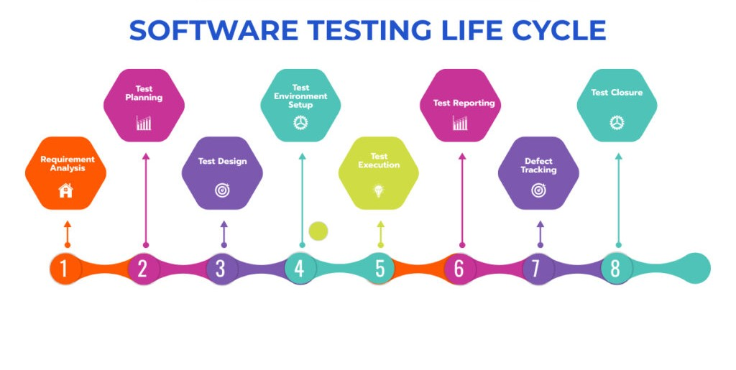
* Test case development: test cases are developed based on the test plan and requirements analysis. Test cases outline the steps to be executed, expected results, and any prerequisites or preconditions.
* Test environment setup: a test environment is created to mimic the production environment as closely as possible. This involves setting up hardware, software, databases, networks, and other dependencies required for testing.
* Test execution: testers execute the test cases developed earlier in this phase. Test execution involves running the test cases, recording the actual results, and comparing them with the expected results.
* Defect tracking: during test execution, defects or issues discovered are logged in a defect tracking system. Each defect is assigned a severity, priority, and status. Defects are then tracked until they are resolved and closed.
* Test reporting: test reporting involves documenting the test results, including the number of test cases executed, passed, failed, and blocked. It also includes summarizing the overall quality of the software and any risks identified during testing.
* Test closure: in this final phase, the testing team evaluates the testing process to identify areas for improvement. A test closure report is prepared, documenting the lessons learned, best practices, and recommendations for future projects.
* The stlc is iterative and may be adapted based on the development methodology used (e.g., agile, waterfall) and project-specific requirements. The goal of the stlc is to ensure that the software meets the desired quality standards and performs as expected in the production.

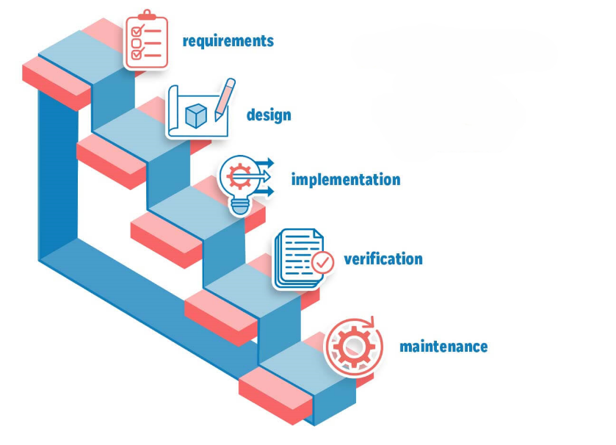**WATERFALL METHODOLOGY:**

Waterfall is a traditional and sequential approach to software development, where each phase of the project is completed before moving on to the next. It follows a linear and structured process, similar to water flowing down in a waterfall, hence the name.

**Phases of Waterfall Methodology:**

* **Requirements Gathering and analysis:**

In this initial phase, the requirements for the project are gathered from stakeholders.

The goal is to clearly define what the software needs to accomplish.

Once requirements are gathered and documented, they are usually considered fixed for the rest of the project.

* **System Design:**

With the requirements in hand, the design phase begins.

This phase involves creating a detailed system design based on the gathered requirements.

Architects and designers create diagrams, wireframes, and other documentation to outline how the system will be structured.

* **Implementation (Coding)/Development:**

In the implementation phase, developers start coding based on the design specifications.

This is where the actual development of the software takes place.

Each piece of the software is developed in isolation based on the predetermined design.

* **Testing and integration:**

After the development is complete, the testing phase begins.

Testers check the software against the requirements to ensure it functions as expected.

Defects or bugs are identified, reported, and fixed.

* **Deployment:**

Once the software has been thoroughly tested and all identified issues are fixed, it is deployed to the production environment.

This phase involves making the software available to users.

* **Maintenance:**

The final phase involves maintaining and supporting the software in the production environment.

Updates, bug fixes, and user support are part of this ongoing maintenance phase.

**Characteristics of Waterfall Methodology:**

**Sequential and Linear:** Each phase must be completed before moving on to the next, with no overlap.

**Fixed Requirements:** Requirements are defined at the beginning and are typically not expected to change during the project.

**Document-Driven**: Emphasis is placed on thorough documentation at each stage of the process.

**Less Flexibility:** Changes in requirements or scope are difficult to accommodate once the project is underway.

**Predictable Timeline:** The timeline and deliverables are often well-defined at the beginning of the project.

**Advantages of Waterfall:**

**Clear Structure:** The sequential nature provides a clear roadmap for the project.

**Thorough Documentation**: Detailed documentation helps in understanding the project's progress and requirements.

**Predictable Costs:** Since requirements are fixed, it's easier to estimate costs upfront.

**Disadvantages of Waterfall:**

**Less Flexibility:** Changes late in the process can be costly and difficult to implement.

**Limited Customer Interaction:** Customers may not see the product until late in the development cycle.

**Risk of Requirement Misunderstanding**: Since requirements are fixed early on, there's a risk of misunderstanding or misinterpretation.

**Longer Delivery Time:** If changes are needed, it might require going back to earlier stages, extending the timeline.

**Advantages of Waterfall Methodology:**

* **Clear and structured approach:** Each stage has well-defined goals and deliverables, making it easy to track progress.
* **Easy project management:** Since requirements are finalized upfront, it simplifies project planning and resource allocation.
* **Suitable for well-defined projects:** When requirements are clear and unlikely to change, waterfall can be efficient.

**Disadvantages of Waterfall Methodology:**

* **Lack of flexibility:** Changes to requirements later in the process can be difficult and expensive to implement. It's like having to change the house layout halfway through construction.
* **High risk in later stages:** Defects found during testing can be costly to fix, as earlier stages may need to be reworked.
* **Limited user feedback:** Since users aren't involved throughout the process, their feedback might be incorporated only at the end, potentially leading to a product that doesn't fully meet their needs.

Waterfall is best suited for projects where the requirements are well-understood, fixed, and unlikely to change. It provides a structured approach that works well when there is a clear path from start to finish. However, in today's rapidly changing environment, Agile methodologies are often preferred for their flexibility and ability to adapt to evolving requirements.

Unlike other methods, such as the Agile methodology, Waterfall doesn’t allow flexibility. You must finish one phase before beginning the next. Your team can’t move forward until they resolve any problems. It is well suited for projects with clear objectives, predictability, and reliability.

**AGILE METHODOLOGY:**

Agile methodology is an iterative and incremental approach to software development, emphasizing flexibility, collaboration, and customer satisfaction. It aims to deliver high-quality software in a more efficient and adaptable manner compared to traditional waterfall methods. Here are the key characteristics of agile methodology:

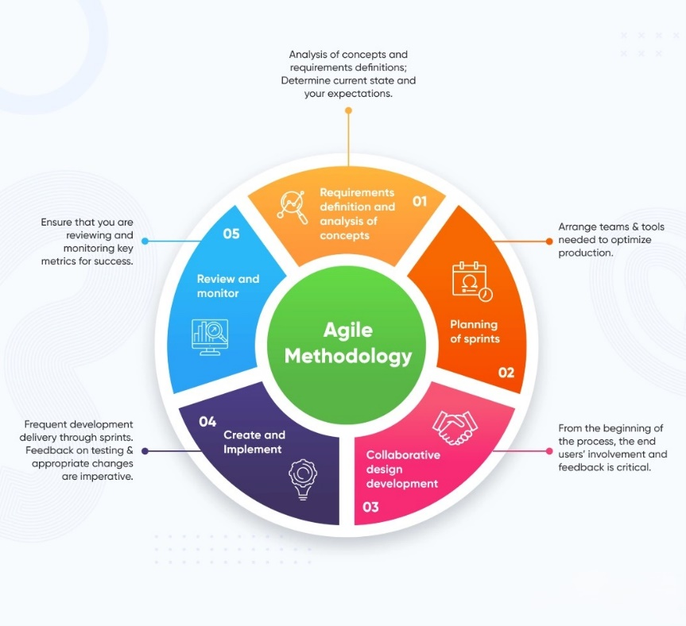

**Iterative Development:** Agile projects are divided into small, manageable iterations called sprints, typically lasting 1-4 weeks. Each sprint delivers a potentially shippable product increment, allowing for continuous feedback and adaptation.

**Customer Collaboration:** Agile methodologies emphasize active involvement and collaboration with customers and stakeholders throughout the development process. Their feedback guides the direction of the project, ensuring that the final product meets their needs and expectations.

**Cross-Functional Teams:** Agile teams are typically cross-functional, comprising members with diverse skills (developers, testers, designers, etc.) who work together collaboratively to deliver value. This fosters a sense of ownership and collective responsibility for the project's success.

**Adaptive Planning:** Agile projects embrace change and uncertainty, prioritizing delivering high-value features based on customer feedback and changing requirements. Planning is done iteratively and adaptively, allowing teams to respond quickly to evolving priorities and market conditions.

**Continuous Integration and Testing**: Agile teams employ continuous integration and testing practices to ensure that code changes are integrated and tested frequently. This helps identify and address issues early in the development process, reducing the risk of defects and integration problems.

**Transparent Communication:** Agile methodologies promote open and transparent communication within the team and with stakeholders. Information radiators such as task boards, burndown charts, and Kanban boards are often used to visualize progress and priorities.

**Iterative Feedback Loops**: Agile teams regularly review and reflect on their work through ceremonies such as sprint reviews and retrospectives. These feedback loops help identify areas for improvement and drive continuous process improvement.

**Focus on Quality:** Agile methodologies emphasize delivering high-quality software by prioritizing quality assurance practices, including continuous testing, code reviews, and refactoring.

Popular frameworks and methodologies within the agile approach include Scrum, Kanban, Extreme Programming (XP), Lean Software Development, and Dynamic Systems Development Method (DSDM).

Overall, agile methodology provides a flexible and adaptive approach to software development, enabling teams to respond quickly to change and deliver value to customers more efficiently.

**Core Principles:**

* **Iterative Development:** Projects are divided into smaller phases called sprints (typically 1-4 weeks). Each sprint focuses on delivering a specific set of features or functionalities. This allows for quicker feedback and adjustments compared to traditional linear development.
* **Continuous Improvement:** Agile emphasizes learning and adapting throughout the project. After each sprint, there's a dedicated time for reflection and improvement. This ensures the team continuously refines their approach based on learnings and feedback.
* **Customer Collaboration:** Agile values close collaboration with customers throughout the development process. Customers are involved in prioritizing features, providing feedback on deliverables, and ensuring the final product aligns with their needs.
* **Empowered Teams:** Agile fosters self-organizing and cross-functional teams. Team members have the autonomy and skills to make decisions and complete tasks effectively.

**Agile Practices:**

* **Backlog:** A prioritized list of features and tasks that represent the overall project requirements. The product owner, who represents the stakeholder interests, typically manages the backlog.
* **Daily Stand-up Meetings:** Short daily meetings where team members share progress, identify roadblocks, and collaborate on solutions. These meetings are crucial for maintaining focus and communication within the team.
* **Agile Retrospective:** After each sprint, the team holds a dedicated meeting to reflect on the past iteration. They discuss what went well, what could be improved, and how to adapt their approach for the next sprint.

**Benefits of Agile Methodology:**

* **Faster Delivery:** By working in sprints, Agile enables quicker delivery of working features and facilitates early customer feedback, leading to a faster time to market.
* **Increased Adaptability:** The iterative approach allows the project to adapt to changing requirements or market demands.
* **Improved Customer Satisfaction:** Continuous customer involvement ensures the product aligns with their needs and expectations, leading to higher satisfaction.
* **Enhanced Team Collaboration:** Agile fosters a collaborative environment where team members work together effectively towards a common goal.

**Common Agile Frameworks:**

* **Scrum:** A popular Agile framework that uses sprints, backlog, and specific roles like Scrum Master (facilitates the process) and Product Owner (represents stakeholder interests).
* **Kanban:** A visual method that uses boards and cards to represent tasks and their workflow stages. Kanban boards help visualize workflow and identify bottlenecks.

**JIRA:**

Jira is a project management tool developed by Atlassian specifically designed for agile teams. It's widely used for various project types, not just software development. Here's a breakdown of what Jira offers:

**Core Functionality:**

* **Issue Tracking:** Jira excels at tracking issues, which can represent bugs, tasks, requirements, or any item requiring work within a project. You can create issues, assign them to team members, track their progress, and prioritize them based on importance and urgency.
* **Workflow Management:** Jira allows you to define workflows that map out the different stages an issue goes through (e.g., To Do, In Progress, Done). This helps visualize the process and ensures everyone follows the established procedures.
* **Agile Support:** Built for agile methodologies like Scrum and Kanban, Jira offers features like sprint planning boards, backlog management, and burndown charts to track progress within each sprint.
* **Reporting and Analytics:** Jira provides reports and insights to help teams monitor progress, identify bottlenecks, and make data-driven decisions.

**Benefits of Jira:**

* **Improved Team Collaboration:** Centralizes communication and task management, fostering collaboration among team members.
* **Enhanced Project Visibility:** Provides a clear overview of project progress, deadlines, and resource allocation.
* **Increased Efficiency:** Streamlines workflows and automates tasks, saving time and effort.
* **Better Decision Making:** Data-driven insights from reports help teams make informed decisions about project priorities and resource allocation.

**Who Uses Jira?**

While Jira started as a software development tool, its flexibility makes it suitable for various teams:

* **Software Development Teams:** Plan sprints, track bugs, manage tasks, and collaborate effectively.
* **Marketing Teams:** Manage campaigns, track deliverables, and streamline content creation workflows.
* **Design Teams:** Collaborate on design projects, track revisions, and manage feedback.
* **Business Teams:** Manage projects, track requests, and improve departmental efficiency.

Atlassian offers different versions of Jira to cater to specific needs:

* **Jira Software:** The most popular version with all the core features for agile software development.
* **Jira Work Management:** Aimed at non-software teams, offering simplified project and task management functionalities.
* **Jira Align:** Enterprise-level solution for portfolio management, enabling visibility across multiple teams and projects.